Bike Sales Dashboard Portfolio Project

🚀 Excited to share the results of my latest Excel project! Its always fun and good to use Excel for performing required analysis 📊💼

🔍 Project Overview: I recently completed a comprehensive financial analysis using Excel to analyze bike sales data to create an interactive dashboard.

📈 Visual Results: Take a look at the charts below showcasing key insights generated from the Excel project.

🔑 Key Features: Leveraged advanced Excel functions including XLOOKUP, pivot tables, and conditional formatting to streamline data analysis and visualization. The dynamic dashboards created allowed for real-time tracking of sales performance.

Sample dataset snip:



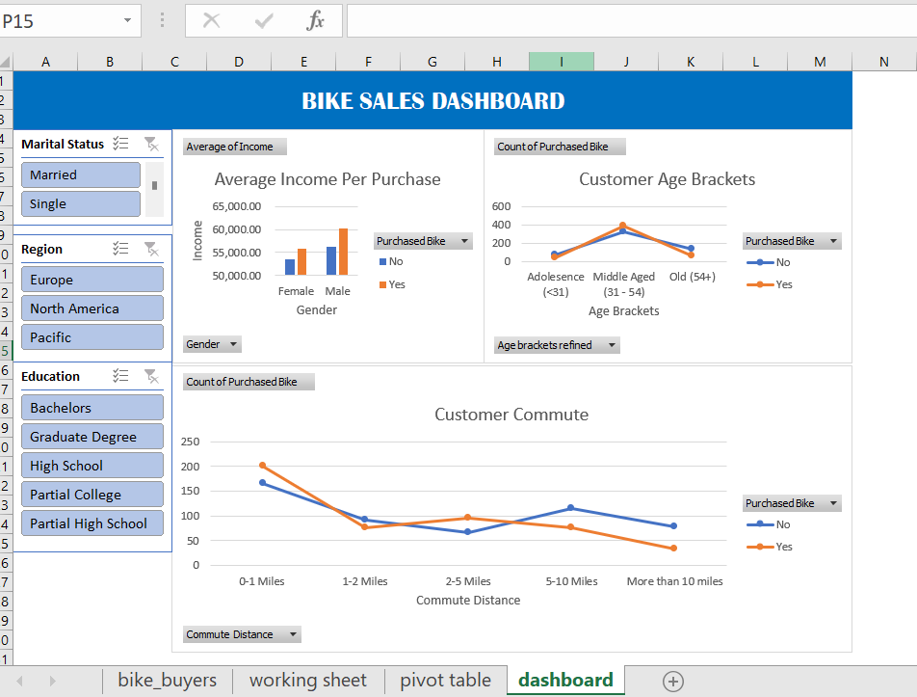

Some of the Steps performed during this dashboard project:

1. Data cleaning steps – removing null and invalid data and removing duplicates
2. Data type validations for columns like Income.
3. Data Validation for (Gender, Marital Status, Commute Distance) and other columns have been worked upon.
4. Feature engineering – to generate new and valid features (creating age brackets, age buckets refined)
5. Creating Dashboards with Slicers to get required filters applied.

